Scottish branch

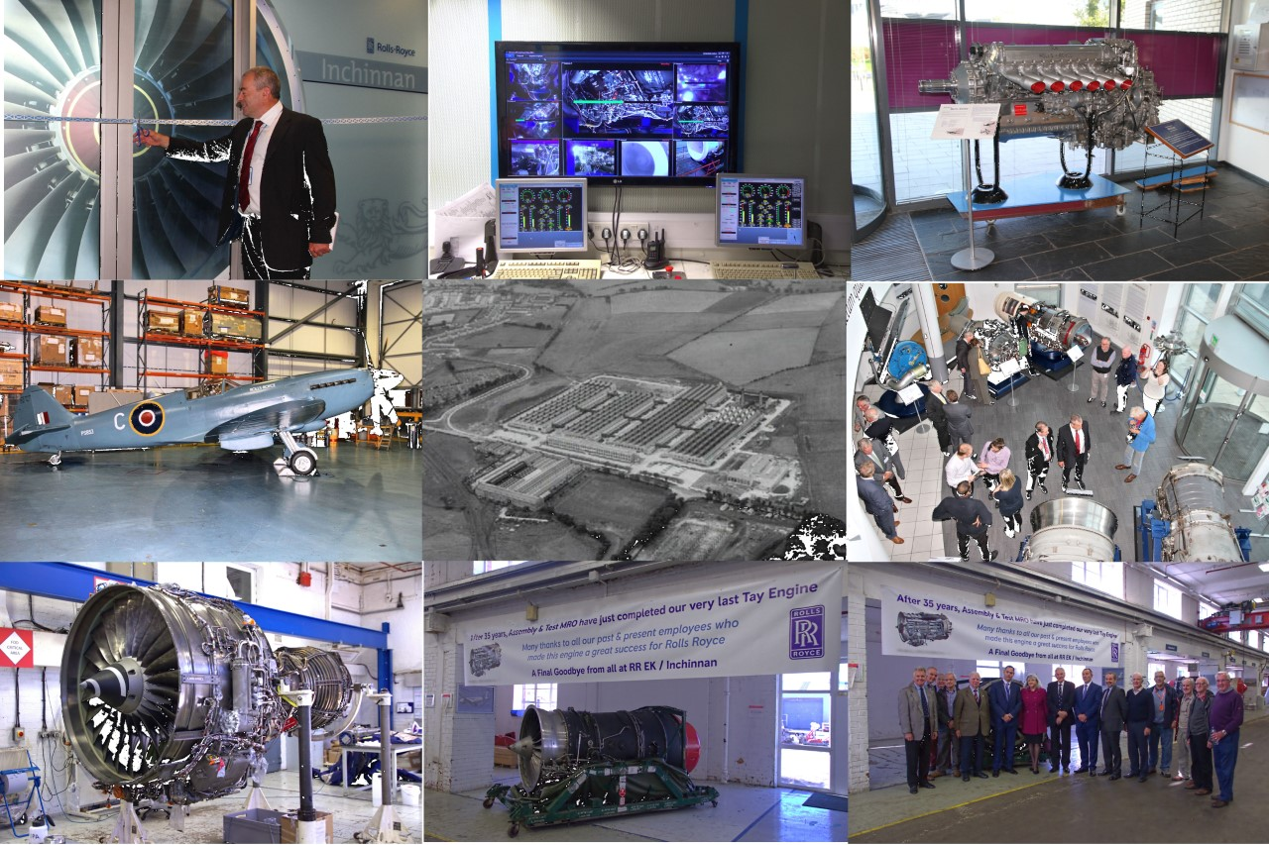

The Scottish Branch Display Engines focus on Rolls-Royce engines from the original Hillington and East Kilbride factories.
The Trust collection in Inchinnan comprises a small, but impressive collection of aero engines.
Exhibits include: Merlin, Derwent, Gazelle, Dart, Avon, Spey, Tay, and Trent 800 model.
The Gill Library is available to members by appointment to come along and browse.

President - John Marsella, Chairman - Graham Carson, Secretary & Treasurer - Janice Thomson
Location of Scottish Branch:
The Rolls-Royce Heritage Trust Scottish Branch
Rolls-Royce plc
Inchinnan Business Park,
Inchinnan , Renfrewshire PA4 9AF
Scotland, UK

Dedicated website contact: Janice Thomson jenni.thomson@hotmail.com

Photos -
Going from left to right starting top row,
1 Opening of Heritage Trust at Inchinnan Sept 2015 by Colin Smith
2 Monitors showing last Tay engine on test at E.K test beds
3 Merlin Engine out on loan to company in Hillington Glasgow.
4 Rolls Royce Spitfire in Loganair Hangar after Flypast August 2014
5 Aerial view of Rolls Royce plant at East Kilbride on completion 1952
6 Foyer at Inchinnan on opening of Heritage Trust Branch Scotland.
7 V2500 engine at Test Beds East Kilbride
8 Last Tay Engine tested at East Kilbride Test Beds.
9 Scottish Branch members at the last Tay Engine Test Beds.

